https://github.com/JhanaR/my_learnReact.git
If need refer below links too
https://github.com/JhanaR/CloneMalini.git
https://github.com/JhanaR/UiClass_React.js-Prereq.git
https://github.com/JhanaR/React_MaliniClass.git
What is Library?
A collection of pre-written code that programmers can use to perform specific tasks or add functionality to a program. Libraries are often written in a specific programming language and are designed to be reusable.
What is React?
React is an open-source, component-based front-end JavaScript library used for building interactive user interfaces, especially for si ngle-page applications (SPAs).
It uses a Virtual DOM instead of directly manipulating the real DOM, which makes UI updates faster and more efficient, It focuses on the view layer of the application, making it lightweight and efficient.
When a component’s state changes,
Render phase – React invokes components to build a new Fiber tree and performs reconciliation process using the Diffing Algorithm.
Commit phase – minimal, synchronous DOM mutations are applied updates only the necessary parts of the real DOM — not the entire page.
it maintains a unidirectional data flow, which makes the application predictable and easier to debug.
What are the major features of React or Purpose of React? Or What are the building blocks of React? Explain with real-time usage.
The main building blocks of React are:
- Components
Web consists of many parts; each part is a component.
Components are independent and reusable bits of code. They serve the same purpose as JavaScript functions, but work in isolation and return HTML.
Each components have states (interface changes) and props are objects (sharing the access with the components, its immutable we can get the data but unable to modify).
- JSX
JSX is a XML-like syntax extension to ECMAScript
JSX stands for JavaScript XML.
It allows you to write HTML-like code inside JavaScript — which makes writing UI components easy and readable.function MyFirstComponent() {
return (
< >
<h1> My First React Component! </h1>
</ >
)

- Prop
Props allow you to pass data and behavior (via functions) from a parent component to a child component.
- State
State is a built-in object in React used to store dynamic data that can change over time and affect the UI rendering.
When state changes, the component re-renders automatically with the new data.
- Hooks
Hooks are special functions in React that let you use state, lifecycle methods, and other React features inside functional components.
- Virtual DOM
The major features of React are:
- It uses VirtualDOM instead of RealDOM considering that RealDOM manipulations are expensive.
what is DOM?
Document object model which represents the web page as a treelike structure which allows JavaScript to dynamically access and manipulate the content and structure of web page, we can achieve everything using Real DOM but the performance will be low.
What is the Virtual DOM and how does it work in React?
The Virtual DOM is a performance optimization technique in React.
It creates a virtual copy of the real DOM, and when changes occur, React uses Reconciliation and the Diffing Algorithm to identify what needs updating.
The React Fiber architecture handles rendering efficiently, breaking it into manageable chunks.
This leads to faster updates and smoother UIs, even in large-scale applications.
What is Reconciliation?
Reconciliation: The process of comparing the previous Virtual DOM with the new Virtual DOM to determine what has changed.
Based on this, React updates only the changed parts in the real DOM.
Diffing Algorithm: Compares the old and new Virtual DOM trees, the minimum number of operations needed to update the real DOM.
What is React Fiber and how does it differ from the old reconciliation algorithm?
React Fiber is the new core algorithm of React that enables better rendering capabilities.
Before Fiber,React used a stack-based reconciliation algorithm which was synchronous and could not be paused
once it started rendering. That meant if React was doing something complex and needed a lot of timeto finish, your UI could freeze or lag.
With React Fiber, rendering became interruptible. Think of it like this — React can now start a task, pause it if something more important comes up (like a user typing), and come back to finish it later. This allows React to prioritize updates and deliver a much smoother user experience.
Key advantages of Fiber: - Interruptible rendering: React can pause, resume, or cancel rendering tasks. - Prioritization: Updates can be categorized as urgent or non-urgent. - Concurrency support: Enables features like time slicing and Suspense.
What is the main goal of React Fiber?
The Reconciliation Phase (Render Phase): This is asynchronous.
- React builds a 'work-in-progress' tree.
- Because it's asynchronous, React can pause this work to let the browser handle a high-priority task (like a user click or animation), then resume or even abort the work if it's no longer needed.
The Commit Phase: This is synchronous.
- This is where React actually applies the changes to the DOM. This must be fast and uninterrupted to ensure the UI remains consistent."
React is Unidirection?
In React, data follows a single direction — top to bottom (from parent → child).
This is called unidirectional data flow.
The parent component manages the state, and passes it down to child components using props.
If a child component needs to update the data, it triggers a callback function provided by the parent, so the parent updates its state and re-renders the necessary components.
This pattern makes the application’s data flow predictable, easier to debug, and improves maintainability.
Difference between DOM and virtual DOM?
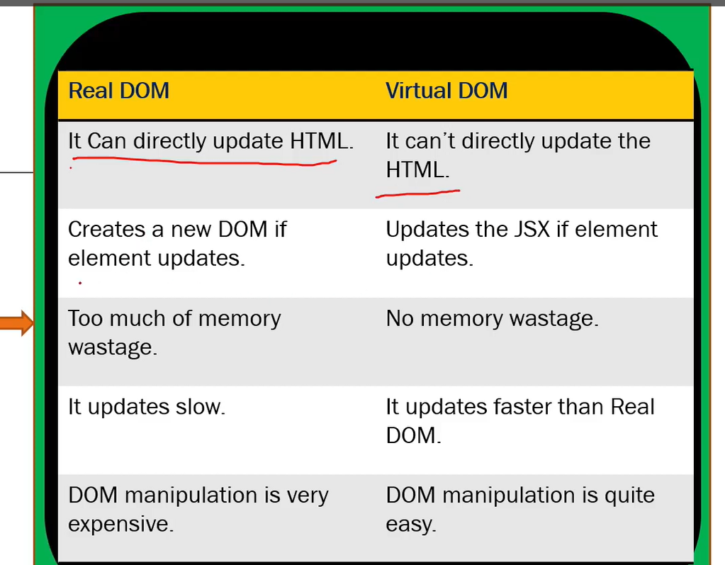
What is the difference between Shadow DOM and Virtual DOM?

Can you explain how React’s rendering process works and how the Virtual DOM helps with performance?
Step-by-Step: React Rendering Process
- State/Props Change
When component state or props change, React re-renders that component (and potentially its children).
- Reconciliation (Virtual DOM diffing)
React builds a new Virtual DOM — a lightweight JavaScript representation of the UI.
It compares the new Virtual DOM with the previous Virtual DOM using the Diffing Algorithm.
Only the elements that changed are identified.
- Batching Updates
React batches multiple state updates together for efficiency instead of re-rendering after each small change.
- Commit Phase (Real DOM update)
React updates only the changed parts in the real DOM (not the whole page) using minimal operations.
How the Virtual DOM Improves Performance
- Direct DOM manipulation is slow because the browser recalculates layout, styles, and paints.
- The Virtual DOM keeps these calculations in memory, reducing costly direct DOM writes.
- By updating only the changed parts, React avoids full page reloads and makes updates faster.
Advantages of React.?
- Used to build sing page Application (SPA) by using components. (React follows component-based architecture which allows developer to use reusable components which can be used throughout the application and that makes its heavy speed.
- React.js is cross flatform and open-source JavaScript framework library, free to use. React is used to develop mobile and applications.
- Light weight and very fast virtual DOM. (Very fast due to Virtual dom)
- Large Community and Ecosystem.
- Testing is easy.
What is React Fiber and how does it differ from the old reconciliation algorithm?
React Fiber is a complete rewrite of React’s core rendering engine introduced around React 16. Its main job is to break rendering work into small chunks and prioritize tasks based on urgency, which allows smoother rendering — especially in large apps.
In older versions of React, the rendering process was synchronous and blocking. So if the UI update was heavy, the browser could freeze.
But Fiber makes rendering interruptible — React can pause work, do something more urgent like handling user input, then come back and continue where it left off.
In short: Fiber brings asynchronous rendering, prioritization, and better user experience.
How does React determine when to re-render a component?
React re-renders a component when:
Its state or props change
Its parent component re-renders, unless it’s memoized

But here’s the twist: React doesn’t do deep comparisons by default. So even if an object or array looks “the same”, if the reference changes, React treats it as different.
That’s why techniques like:
React.memo()
useMemo()
useCallback() are important in performance tuning — they help you avoid unnecessary renders when data hasn’t really changed.
Bonus: The key prop also plays a role in determining if elements inside a list need to be re-rendered or not.

What are concurrent features in React and how do they help?
Concurrent features — introduced in React 18 — allow React to prepare multiple versions of the UI at the same time.
Let’s say a user is typing a search query and you’re fetching filtered results. Without concurrency, the UI could feel laggy. But with concurrent rendering, React can keep the UI responsive while preparing the new result list in the background. Features like startTransition , useDeferredValue , and automatic batching allow this.
So, concurrent features are like giving React multitasking superpowers — it can prioritize urgent updates like user input over non-urgent tasks like data fetching.
Explain React's batching behavior and what changed in React 18.
Batching means React groups multiple state updates into one render to improve performance.
Before React 18, batching only worked inside React event handlers. If you updated state inside a setTimeout or fetch().then() , those updates triggered multiple renders.
React 18 introduced automatic batching — so now, even updates inside promises, setTimeout , or native events are batched by default.
This means fewer renders, better performance, and more predictable behavior across async code.
What is the difference between useMemo and useCallback, and when not to use them?
useMemo is used to memoize values
useCallback is used to memoize functions
They both prevent re-creation on every render, but people often overuse them.
Here’s the deal: if the memoization is more expensive than recalculating the value, you're actually hurting performance. Only use them if:
The value/function is heavy to compute
It causes unnecessary re-renders in children
Think of them as performance tools, not default habits.
How does Suspense work, and what are some real use cases beyond lazy loading?
React.Suspense lets you wait for something — like a lazy-loaded component or even data fetching (when used with libraries like React Query, Relay, or SWR).
You wrap a component with <Suspense fallback={<Loading />}> , and while the content is loading, React shows the fallback.
Beyond just lazy loading:
You can use it with streaming SSR (in Next.js)
You can coordinate parallel data loading
You can delay transitions to avoid layout shifts
It’s about better UX during loading states, not just code splitting.
What is useImperativeHandle and when should you use it?
This one’s niche, but powerful.
useImperativeHandle is used with forwardRef to expose custom methods from a child component to a parent, instead of exposing the full DOM ref.
For example: You have a custom Input component and you want to expose a focus() method to the parent. Instead of giving full DOM access, you expose just that method through useImperativeHandle .
It’s a way to keep encapsulation, while still giving the parent controlled access.
How do you optimize large lists in React?
Rendering thousands of items can crash the browser.
To solve this:
Use windowing libraries like react-window or react-virtualized
Render only the visible portion of the list
Use key props properly
Combine with memoization (e.g., React.memo ) to avoid re-rendering unchanged items
Think of it like a Netflix carousel — you only render what the user sees. This saves memory, time, and power.

How does useRef differ from useState?
useRef holds a mutable value that doesn’t cause re-renders when it changes. useState holds values that do trigger re-renders.
Use useRef for:
DOM refs ( ref={myRef} )
Storing timers, counters, or previous values
Avoiding re-renders on updates
So:
useState = React cares when it changes
useRef = React ignores the change
How does React handle hydration in SSR, and what problems can arise?
Hydration is the process where React attaches event listeners to server-rendered HTML on the client.
The problem is — if the HTML rendered on the server doesn’t match what the client renders, you get a hydration mismatch warning.
Common causes:
Using random values (like Math.random() ) during render
Accessing window or localStorage on the server
Not wrapping async components in <Suspense>

Hydration issues are subtle but can break your UI in production — so always test SSR apps thoroughly.
What is SINGLE PAGE APPLICATION.?
The web page which consists many components, if there is any change/ update in any component, only that content in the component is dynamically updated instead of refreshing the whole page.
What is JSX?

In how many ways you can create Component ?
Components come in two types, Class components and Function components
What are the main differences between class components and functional components?
Class components use lifecycle methods (ComponentDidMount,componentDidUpdate CompoentWillUnmount etc.) and manage state with this.state, whereas functional components are simpler, using Hooks like useState, useEffect, useRef, useMemo, useCallback, useContext to manage state and side effects.
Real-time Note:
Since React 16.8, Hooks made functional components more powerful, and now most codebases—including ours—prefer function components for cleaner, testable code.
What are Props ?
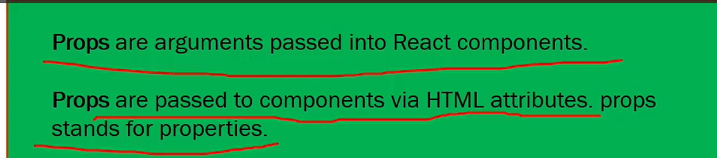
Why we use Props ?
Props allow you to pass data and behavior (via functions) from a parent component to a child component.
Hint: If you want to access a property in a child object even when the parent doesn't have that property, it will not throw an error.
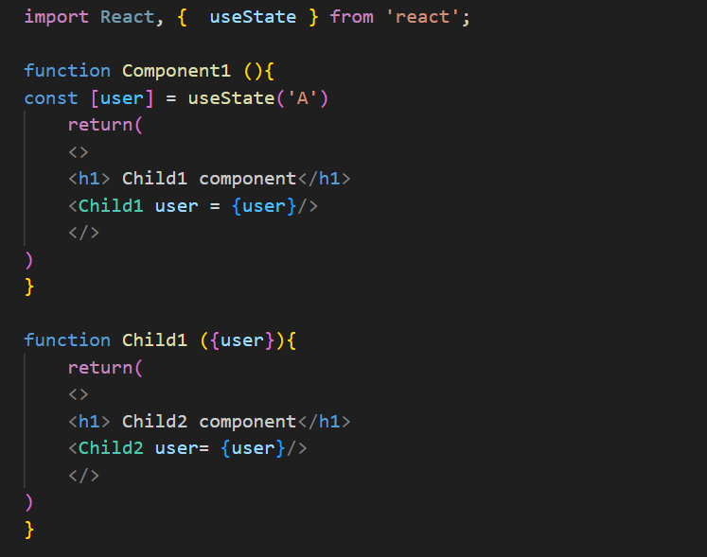
Can you explain the difference between state and props? OR How is state different from props in React?
Props and state are both used to manage data in React, but they serve different purposes.
🔹 Props (short for "properties") are used to pass data from a parent component to a child. They are read-only from the child’s perspective, ensuring unidirectional data flow. This promotes component reusability and predictable behaviour.
🔹 State, on the other hand, is a local, mutable data container managed within the component itself using the useState (or useReducer) hook. When state updates, it triggers a re-render, allowing dynamic UI updates based on user interactions or side effects.
In short, props are for configuration, while state is for internal data that may change over the component’s lifecycle.
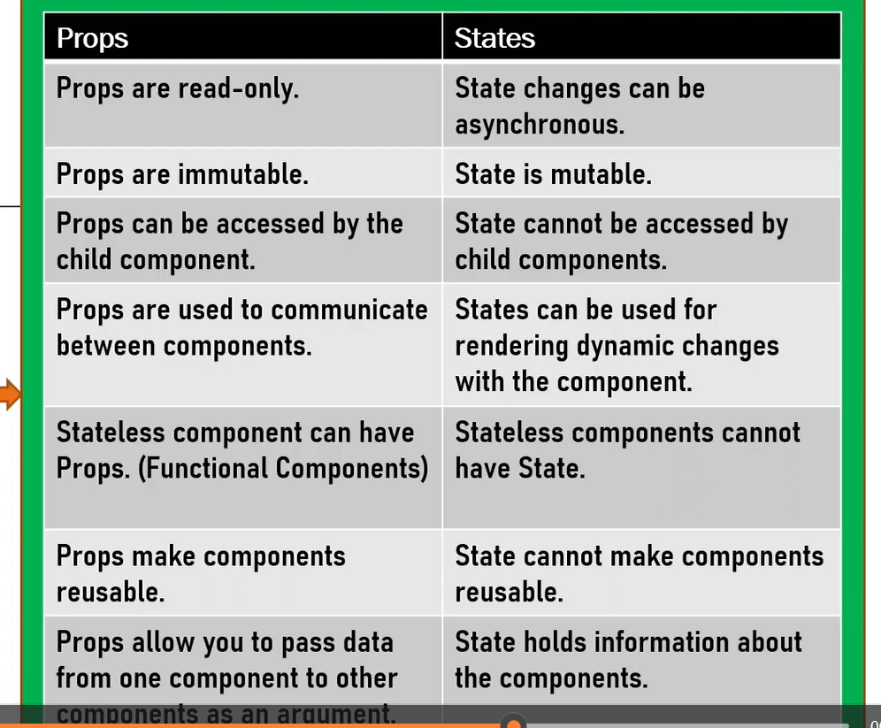
How do you pass data from parent to child and vice versa?
What happens if both props and defaultProps are provided?
The value passed from the parent (via props) overrides the defaultProps value.
What is key in React?
The key is a special prop used by React to identify which items in a list have changed, been added, or removed.
It helps React optimize rendering by reusing elements instead of re-creating them from scratch.
What is data binding in React? Explain the types with examples.
Data binding in React refers to the connection between UI elements (like inputs, text) and the component’s data/state.
It determines how changes in the state reflect in the UI and how user input updates the state.
React supports mainly one-way data binding from parent to child using props, and it allows you to simulate two-way binding in controlled components.
You manually bind the input value to state, and update the state on input change.
how can you create reference for element in functional Component ?

What is the difference between an Element and a Component?

What is the diff between functional and Class components?
How do you create components in React?
What are Pure Components?
What are React hooks? Name a few?
React Hooks are special functions introduced in React 16.8 that let you use state and other React features in functional components without writing class components.
useState – For managing local component state.
useEffect – For handling side effects (API calls, subscriptions, DOM updates).
useContext – For accessing React Context values.
useReducer
useRef – For persisting values across renders without triggering re-renders.
useMemo – For memoizing values to avoid expensive recalculations.
useCallback – For memoizing functions to prevent unnecessary re-creations.
React uses a Virtual DOM — a lightweight copy of the real DOM.
When state/props change, React:
- Re-renders the component in Virtual DOM.
- Diffs the new Virtual DOM with the previous one using a process called Reconciliation.
- It then batches minimal updates to the real DOM, which improves performance.
React also uses Fiber architecture (since v16) to break rendering into units of work, allowing interruptible rendering for smooth UX.
What is state and How to Update State ?
state is an object that holds or allows you to store property values that belong to the component that may change over the lifetime of a component. It is essentially the data that drives the behaviour and appearance of your component. When the state of a component changes, React re-renders the component to reflect the updated state.
- Each component can have its own state.
- The state is mutable, meaning it can change over time, usually in response to user actions or network responses.
- State is used in class components as this.state and in functional components using useState hook.
- The useState hook returns an array with two elements: the current state value and a function to update it.
- Example: Build a simple counter app using React hooks.
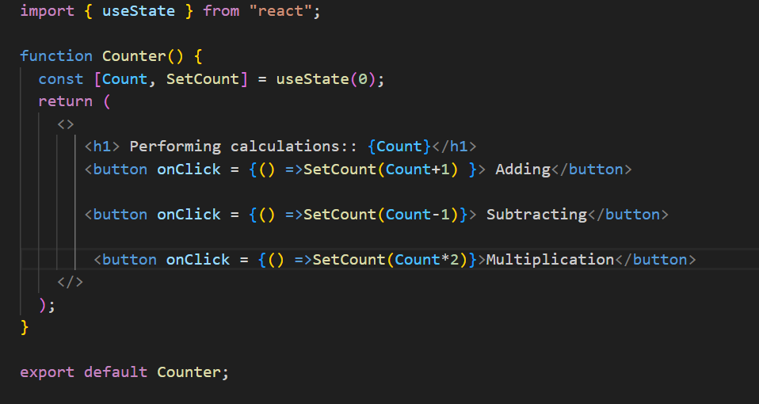- Here, `count` is the current state, and `setCount` is the function to update the state.
State management is a core concept in React, enabling you to create interactive and dynamic user interfaces.
What happens when setState() is called ?
React initiates an efficient, batched update process that eventually leads to the component being re-rendered with the updated state, ensuring that the UI stays in sync with the underlying data.
What happens in React when you click a button that updates state?
When I click a button that updates the state using useState, react re-renders the component with the new state value. Under the hood, React uses the Virtual DOM to compare the previous state and the new one. It then updates only the changed parts in the real DOM using a diffing algorithm, improving performance.
What are React Hooks? Which ones do you use most often?
There are two main rules of using Hooks in React:
- Only call Hooks at the top level.
Don’t call them inside loops, conditions, or nested functions. This ensures Hooks are called in the same order every time a component renders.
- Only call Hooks from React functions.
You can use Hooks inside:
  - Functional components
  - Custom Hooks
But not in regular JS functions or class components.
Hooks are functions introduced in React 16.8 that let you use state and lifecycle methods in functional components.
- Simplify state management in functional components with useState.
- Perform side effects with useEffect.
- Access context values with useContext.
- Manage complex state logic with useReducer.
- Optimize performance with useMemo and useCallback.
- Access and persist values or DOM elements with useRef.
I frequently use:
- useState for managing local state
- useEffect for side effects (like fetching data)
- useRef for storing mutable values or DOM refs
- useContext for global/shared state
What is useState?
useState is a React Hook that allows functional components to have local state — enabling them to hold and update values that trigger re-renders.
What triggers a re-render?
Calling setState (e.g., setCount) triggers a re-render with updated UI.
Purpose of useState?
To manage dynamic data inside functional components.
Trigger re-renders when the state changes.
Encapsulate UI behavior like toggling, counters, inputs, modals, etc.
When to Use useState?
You need to track a value over time (e.g., input field, counter, toggle).
- A value needs to re-render the UI when changed.
- You want local component state (not global or shared state).
- The state doesn't need persistence across routes/pages or deep component trees.
Why is key concept in React important?
Keys help React identify which items have changed in a list, making updates more efficient.
What is useEffect or how useEffect will maintain 3 lifecycle method ? OR explain useEffect — how does dependency array work?
useEffect is a React Hook used to handle side effects in functional components — like fetching data, setting up subscriptions, or manually manipulating the DOM.
It replaces the old lifecycle methods from class components:
- Acts like componentDidMount when the dependency array is empty.
useEffect(() => {}, [])
Like componentDidMount in class components.
Used for initial data fetch, API calls, subscriptions, or timers, etc.
Trigger count: 1 (after first render)
- Acts like componentDidUpdate when specific dependencies are listed.
useEffect(() => {}, [someValue])
Runs after first render, and then whenever someValue changes
Like componentDidUpdate (for that value).
Acts like componentWillUnmount
useEffect(() => {})
Runs after every render (initial + all updates)
Like combining componentDidMount and componentDidUpdate
What is useEffect used for?
useEffect runs side effects like API calls, subscriptions, or timers.
You can control when it runs using the dependency array:
[] → runs only once (like componentDidMount)
[dep] → runs when dep changes(like ComponentDidUpdate)
no array → runs on every render( like componentWillUnmount)
return () => clearTimeout(timer);
This is the cleanup function of useEffect. It runs before the next effect is applied.
The cleanup function in useEffect is used to remove things like event listeners, timers, or subscriptions to prevent memory leaks. It runs when the component unmounts or before the effect re-runsz
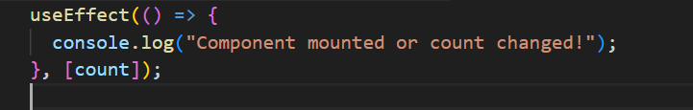
What hook runs on every render by default?
The useEffect() hook runs on every render by default, unless we provide a dependency array.
If no second parameter is given, React assumes it should run the effect after every re-render.
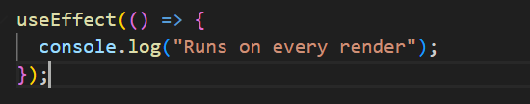
What’s the second parameter in useEffect?
The second parameter is the dependency array. It tells React when to re-run the effect:
- [] → run once on mount (like componentDidMount)
- [value] → run only when value changes
- No array → run on every render
What happens when you call setState inside useEffect without a dependency array?
If you call setState inside a useEffect without passing a dependency array.
stale
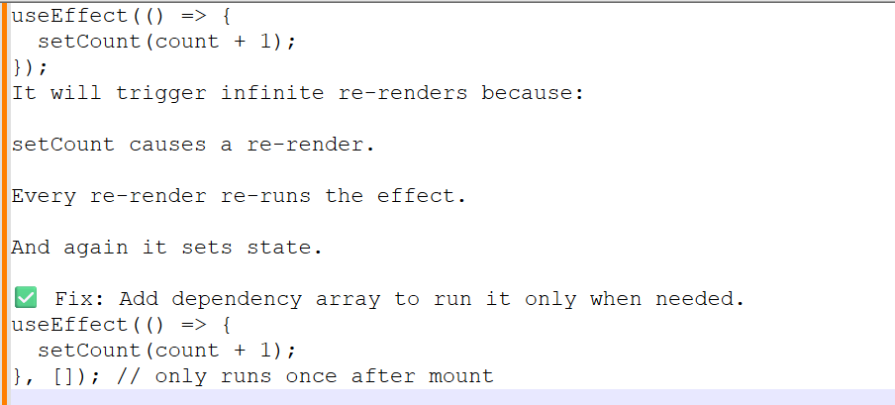
How do you pass data from parent to child and vice versa?
Have you used Redux or Context API? Explain with example OR What is the useContext hook and when would you use it?
The useContext hook is used to access the value of a React Context directly inside a functional component, without the need for prop drilling.
It’s ideal for sharing global state like:
- Themes (e.g., dark/light mode)
- Authentication status
- User preferences or language settings
I’ve used useContext in large UI apps to manage layout preferences like dark mode or sidebar visibility — avoiding unnecessary Redux setup or passing props deeply through multiple components.
For more complex shared state, I’ve combined useContext with useReducer to manage state transitions cleanly while still avoiding external state libraries.
What is Context Api and Why do we use Context API ?
- Context API is a way to pass data through the component tree without having to pass props down manually at every level.
- Use Case: It's primarily used to avoid prop drilling and to manage global state that needs to be accessed by multiple components.
- Key Components: createContext, Provider, Consumer (or useContext hook).
- Advantages: Simplifies state management for certain use cases, reduces dependency on parent components, and provides a more maintainable and scalable solution for passing data across components.
Which kind problem will be solved using Context API ?
The Context API is a powerful tool for solving various problems related to state management and data sharing in React applications, including:
- Avoiding prop drilling.
- Managing global state.
- Decoupling components.
- Sharing configuration or constants.
- Handling user preferences or localization.
How do you manage global state in React OR How do you manage global state in your application?
For simple shared state, I use the Context API. If the app grows complex, I use Redux Toolkit or Zustand.
Context is great for theme, auth, or language settings.
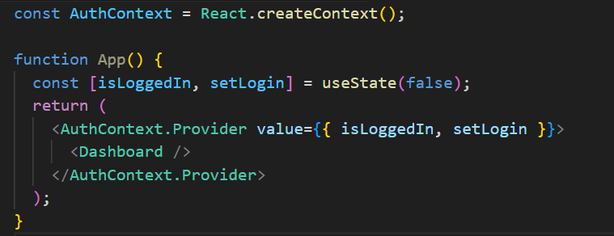
What is use Reducer and for what purpose it is used for?
What is useMemo and for what purpose it is used for and when should you use it?
used to memoize the result of a computation, so it only re-computes when its dependencies change.
It helps improve performance by avoiding expensive calculations on every render.
Prevents unnecessary recalculation (e.g., doubleCount)
What is useCallback?
Prevents function prop from being recreated (e.g., onGreet)
useCallback is used to memoize functions, ensuring they're only recreated when their dependencies change.
This is particularly useful when passing callbacks to memoized child components (like those wrapped with React.memo) to prevent unnecessary re-renders caused by changing function references.
It helps improve performance in component trees where rendering logic is heavy or deeply nested.
In a large-scale UI, I’ve used useCallback to stabilize handler functions that were passed into child dropdowns or reusable lists, avoiding performance issues from repeated renders during user interactions.
What is React.memo and useCallback?
- useCallback(fn, deps) returns a memoized function avoid rendering a function.
- useMemo(() => compute, deps) returns a memoized value—avoid rerunning expensive calculations.
Both are used to avoid unnecessary recalculations or re-creations.
What is the children prop?
cWhat is HOC (Higher-Order Component) in React?
A Higher-Order Component (HOC) in React is an advanced pattern used to enhance the behaviour of a component by wrapping it with additional logic. Technically, an HOC is a function that takes a component as input and returns a new enhanced component with additional features or props.
When to Use HOC?
Use HOCs when you want to reuse logic across multiple components without duplicating code.
Examples:
- Authentication/Authorization
- Logging
- Role-based access
- Conditional rendering
- Injecting common props or behavior
Where to Use HOC?
- Wrap UI components that need common logic
- Place them in a separate file (withAuth.js, withLogger.js, etc.)
- Use them to wrap components in your routing or layout structure
What are common issues with stale closures in React? Explain with an example?
A stale closure happens when a function holds on to an outdated value of a variable from an earlier render.
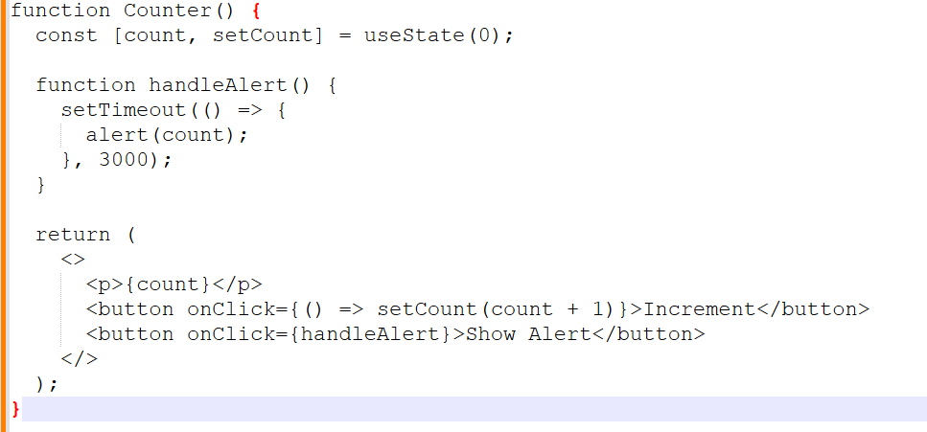
If you click Increment once (count becomes 1), then click Show Alert, after 3 seconds you'll still see 0.
Because the closure captures old value of count
What is useRef?
Using useRef (to avoid stale closures in setTimeout, setInterval, or event handlers)
It doesn’t trigger re-render.
OR
useRef is used to create a mutable reference that persists across renders without causing re-renders.
Common use cases:
- Accessing DOM elements (e.g., focusing an input)
- Storing previous values
- Holding timers or interval IDs
It’s like a container that doesn’t trigger a re-render when updated.
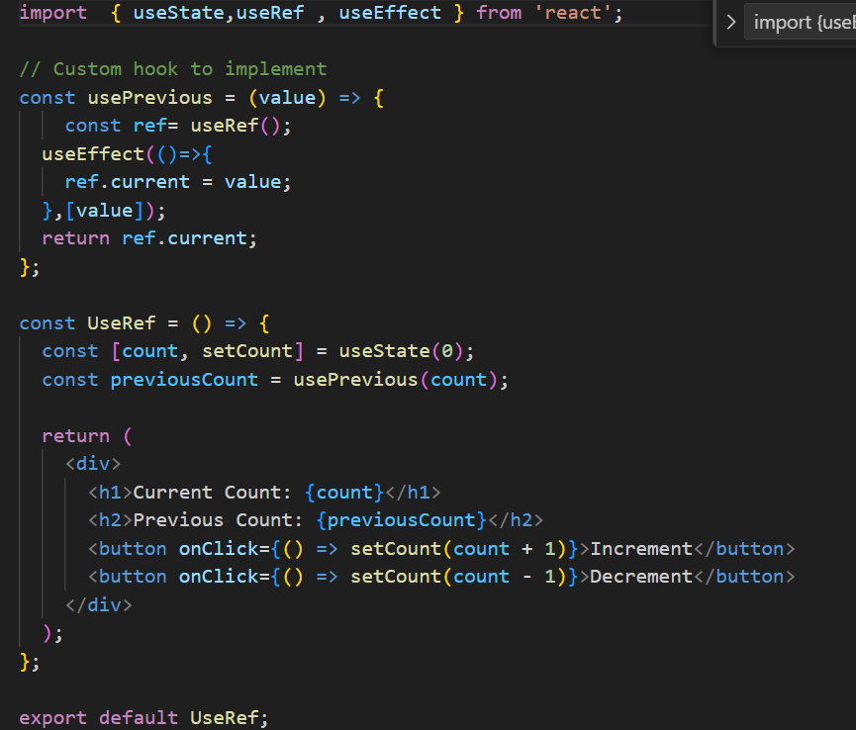
Compare useRef vs prevCount?
useRef
To access the latest state/value inside:
- setTimeout, setInterval, or event listeners
- Without causing re-renders

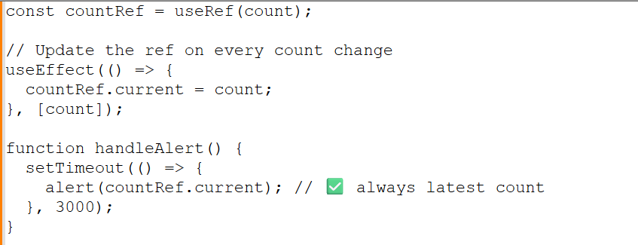
Prev
When updating state based on previous value, especially in:
- Loops
- Multiple state updates in a row
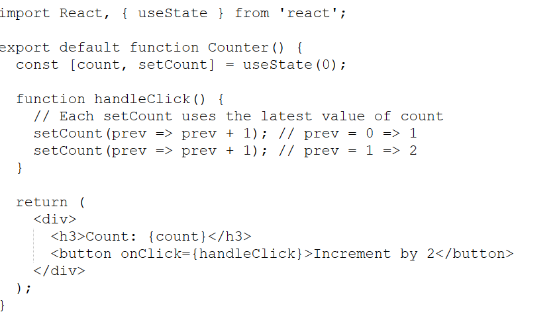
HINT:
You want to do setState twice based on old state setCount(prev => prev + 1)
You want to read latest state in setTimeout useRef + useEffect
You want to update some state but not re-render useRef
You want to persist value between renders useRef
How do you handle API calls in React?
- I use useEffect() to fetch data from APIs. I also handle loading and error states for a better user experience.
Difference between React Router v5 and v6
How do you handle error boundaries in React?
Only class components can be used as error boundaries. You wrap components inside an Error Boundary to catch rendering errors and prevent breaking the entire app.
Error boundaries catch JavaScript errors in child components during rendering, in lifecycle methods, and in constructors. They are implemented using class components with componentDidCatch and getDerivedStateFromError.
As a lead, I recommend wrapping high-risk areas like remote data UIs and using logging services like Sentry.
Code — Build a To-Do App using Hooks
What is server-side rendering and Client-side rendering?
What is the difference between createElement and cloneElement?
What are controlled and uncontrolled components?
Controlled
React fully controls the form input using useState.
The value of the input is bound to a state variable.
Input changes are tracked with onChange() and update the state.
The input elements receive their current value from the state and have their value updated through a callbackfunction.
Controlled components are preferred in React because they make the data flow predictable and easy to validate
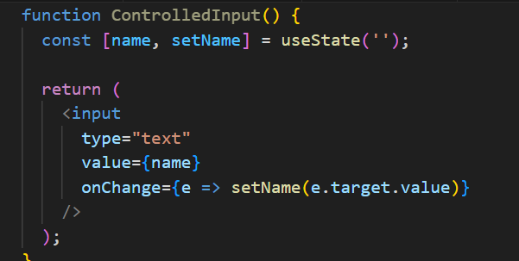
In uncontrolled components
React does not control the input state.
Uses a ref (useRef in functional components) to access the DOM element and get its value.
Input state is maintained by the DOM, not React.
Uncontrolled components may be used for quick forms, performance-sensitive parts, or third-party libraries.
Useful when you don’t need to track the input value on every change

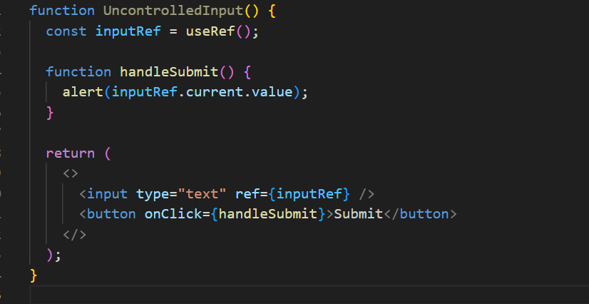
How do you optimize performance in React?
Use React.memo to prevent unnecessary renders
Split code using lazy loading and Suspense
Use proper keys in lists
Avoid anonymous functions in render
How does React handle reconciliation?
React uses the reconciliation algorithm to compare the current Virtual DOM with the previous one and applies minimal changes to the real DOM using keys and component types.
How to prevent re-render in a child component?
Use React.memo() to memoize the child component. It prevents re-render unless props actually change.
Also Avoid
Passing new inline functions or objects as props (unless wrapped in useCallback or useMemo)
Changing parent state unnecessarily
How to persist state between refreshes?
Use localStorage, sessionStorage, or even IndexedDB to persist state across refreshes.
How to create Parent Child Relation ?
Creating a parent-child relationship in React involves nesting components, where one component (the parent) renders another component (the child) and often passes data or functions as props.
What is Application Flow ?
App Initialization: The React app starts, and the root component (<App />) is rendered.
User Logs In: The user inputs credentials into a form and submits it.
State Update: The login form triggers an API call to validate the user. Upon success, the user’s data is stored in the global state.
Navigation: The user is redirected to the dashboard, where the relevant data is displayed.
Data Fetching: The dashboard component fetches additional data (e.g., user’s recent activity) and updates its state accordingly.
User Interaction: The user interacts with various elements on the dashboard, triggering updates in the UI and possibly making further API calls.
Logout: The user logs out, triggering a cleanup of user data from the state and redirecting back to the login page.
What is diff between render() in React and render() in ReactDOM ?
render() in React
- The render() method is a lifecycle method in class components that defines what the component's UI should look like.
- Purpose: It returns the JSX that represents the component's structure. This JSX is then converted to actual DOM elements by React.
- render() function from the ReactDOM library is used to render a React element (or component) into a specified DOM container on the page.
render() in ReactDOM ?
- Purpose: It serves as the entry point to rendering a React application or component tree into the DOM.
In how many ways we can pass the data from parent to child ?
- Props: The most straightforward and common way to pass data.
- Callback Functions: Allows the child to communicate back to the parent.
- Context API: Useful for avoiding prop drilling in deeply nested components.
- State Management Libraries: Ideal for complex, large-scale applications.
- Render Props: A pattern for passing data in more dynamic scenarios.
- Higher-Order Components (HOCs): A pattern for sharing logic between components.
- Composition: Passing JSX or components through the children prop for more flexible component design.
In how many ways you can manage state in React Applicatiion ?
- Local State (useState, setState): Best for managing state within individual components.
- Derived State (useMemo, useCallback): Useful for optimizing performance by memoizing expensive calculations or functions.
- Lifting State Up: Essential for sharing state between sibling components.
- Context API: Ideal for sharing state across a component tree without prop drilling.
- Redux: A powerful, widely-used global state management solution, especially in large applications.
How do you manage state in a complex React application?
For local state, I use useState or useReducer.
If multiple components share state (e.g., filters or user session), I prefer Context API for light use-cases.
For large-scale or asynchronous flows, I use Redux Toolkit — it's clean, maintainable, and handles middleware like createAsyncThunk.
As a lead, I ensure we don't overuse global state and keep components pure and reusable.
What are controlled vs uncontrolled components in React?.
A controlled component has its input value bound to React state via useState.
An uncontrolled component uses ref to access the DOM value directly.
Controlled inputs give you more control over validation and user feedback, but for file uploads or 3rd-party plugins, uncontrolled may be better.
I guide my team to stick to controlled inputs for consistency in enterprise apps.
Explain a challenging UI you built and how you approached it.
How do you ensure performance optimization in your React app?
How do you handle errors and loading states in your app?
Have you worked with any UI libraries like Material UI or Ant Design?
How do you collaborate with backend developers in your project?
What tools do you use for testing your React app?
Have you done deployment of your React app? How?
What is axios ?
Axios is a powerful and flexible library for handling HTTP requests in JavaScript applications. Its features, such as promise-based handling, support for various HTTP methods, interceptors, and built-in error handling, make it a popular choice for making network requests and integrating with APIs in both browser and Node.js environments
Anything alternate to axios ?
Fetch API: Native, modern, and flexible; built into browsers.
jQuery AJAX: Part of jQuery; suitable if you're already using jQuery.
Superagent: Lightweight and flexible with a simple API.
Got: Advanced features for Node.js environments.
Ky: A small and elegant wrapper around Fetch.
node-fetch: Provides Fetch functionality for Node.js.
Apollo Client, Relay: Specialized for GraphQL queries and state management.
How to implement the routing the react application ?
React Router is the most commonly used library for routing in React applications.
Basic Setup: Install React Router, create components, and define routes using BrowserRouter, Routes, and Route.
Navigation: Use Link instead of traditional <a> tags for navigation.
Nested Routes: Define nested routes using Outlet.
404 Handling: Add a fallback route for handling non-existent paths.
What is State Mangement?
In React, state management is about handling UI, shared, and server data efficiently.
For local state, I use useState or useReducer.
For shared/global state, I use useContext, or Redux if the app is large.
For API data, I prefer using React Query to manage caching, loading, and error states easily.
In real projects, I’ve used useContext with useReducer for lightweight state management in layout controls, and Redux for complex apps like e-commerce dashboards.
How do you optimize performance in a large-scale React app?
Performance optimization involves:
- Code-splitting using dynamic import() and React.lazy
- Memoization with React.memo, useMemo, and useCallback
- Avoiding unnecessary re-renders using pure components
- Virtualizing long lists using react-window
- Debouncing and throttling user inputs
- Implementing lazy loading of routes and images
- Using Profiler API to analyze performance
Why hooks were introduced?
Hooks were introduced to:
- Simplify state management and side effects in functional components.
- Facilitate the reuse of stateful logic through custom hooks.
- Improve the readability and maintainability of components.
- Align with functional programming principles.
- Avoid issues associated with complex component hierarchies and wrapper hell.
What is the use of useContext() ?
The useContext() hook in React is used to access the value of a context in functional components. Context is a way to pass data through the component tree without having to pass props down manually at every level.
What is the diff btw useState and useReducer?
Encourage useReducer for:
- Complex forms
- Nested state objects
- Undo/redo features
Use useState for:
Simple toggles
Primitive values
Quick UI flags
What is the use of custom Hooks ?
Functional component | Class component
No need to import react. | Import of (react & component) must include
Normal function syntax with return () is must. | Class App extends Component is must, in order to act as react component
light weight | Extra structure is needed.
Destructing will be done by passing within args | Extra line needed for destructuring,  Method and variables
Here we cannot use life cycle methods in functional components we can handle it using HOOKS except ComponentDidCatch error boundaries. (higher level error catch). | Render () is also react lifecycle method.
 | Mounting- ComponentDidMount
 | Updating- ComponentDidUpdate
 | Unmounting- ComponentWillMount
function Heva (){  return (  <>  <p>She is playing</p>  <p>Here hobby is playing</p>  </>  )  } | Class component: Methods and  import React, { Component } from 'react';  class classComponent extends Component {  render() {  return (  <div>  </div>  );  }  }  export default class;

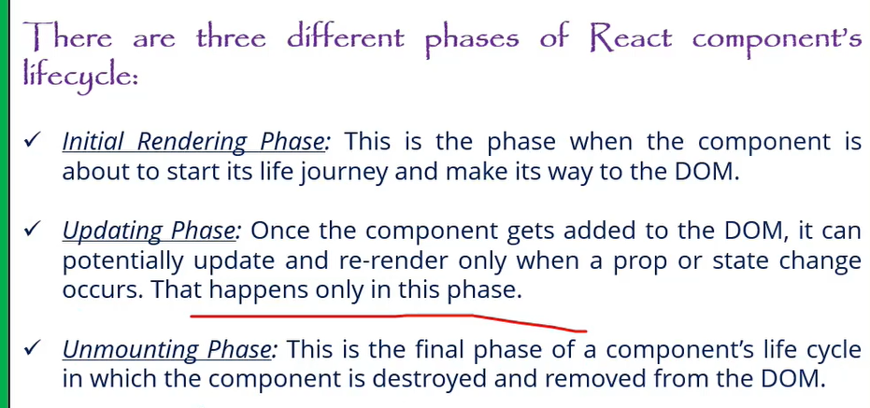
Can you explain the main differences between React class components and functional components with hooks? Why might you choose one over the other?
Lifecycle Methods in Class Components:
- **Mounting:** - `componentDidMount`: Called once the component is mounted.
- **Updating:** - `componentDidUpdate`: Called after the component updates due to changes in props or state.
- **Unmounting:** - `componentWillUnmount`: Called right before the component is unmounted and destroyed.
Note: `componentWillMount` is not recommended for use anymore due to potential issues and is considered legacy. For mounting, use `componentDidMount` instead.
2. **Functional Components with Hooks:**
- Functional components do not have lifecycle methods directly. Instead, you use hooks to achieve similar functionality:
- **`useEffect` Hook**: This hook can replicate `componentDidMount`, `componentDidUpdate`, and `componentWillUnmount` behavior. By specifying dependencies, you can control when effects run.
- **`useState` Hook**: Used for managing state in functional components, replacing the need for `this.state` and `this.setState`.

**Why Choose One Over the Other?**
- **Functional Components**: Generally preferred for their simplicity and ease of use. Hooks make it easier to share logic and manage state without worrying about the complexity of class components.
- **Class Components**: Might be used for legacy codebases or when you need specific lifecycle methods not yet covered by hooks (although hooks generally cover all use cases).

Would you like to elaborate more on this or move to the next question?
what are the main files in React.js
Minimum 6 filers are.
- Index.html file- Though single page application which is under public folder.
- Components The components which should be in application are used to place under src folder only.
- App.js Main component. or root components
- App.test.js- unit test
- Index.css- glogal css file.
- Index.js file entry point of javascript file
Why to use React over other framework?
• Performance: React excels at handling dynamic UIs with
minimal re-renders, keeping your app fast and snappy.
• Composability: React components promote code reusability,
making development faster and easier to maintain.
• JSX: JSX syntax blends JavaScript with HTML, making UI
creation intuitive for developers.

Large Community: A vast community and ecosystem provide support,
libraries, and tools for rapid development.
What’s your approach to debugging in React?
What is lazy loading and How do you implement lazy loading in React?
Lazyloading?
Lazy loading in React helps optimize performance by loading components or resources only when they are needed. You can use React.lazy and Suspense for components, dynamic imports for assets, and libraries like react-lazy-load-image-component for images. This technique reduces initial load time and improves user experience.
What is Async task in react?
Usually it won’t run on renders it performs API calls,
Arrow function expression in React.js?
Arrow function is a way of declaring the function using the arrow operator where first pass the parameters in the bracket then put the whole logic.
Difference we don’t need to add function and function name.
Assigning function itself to a variable.
React hooks
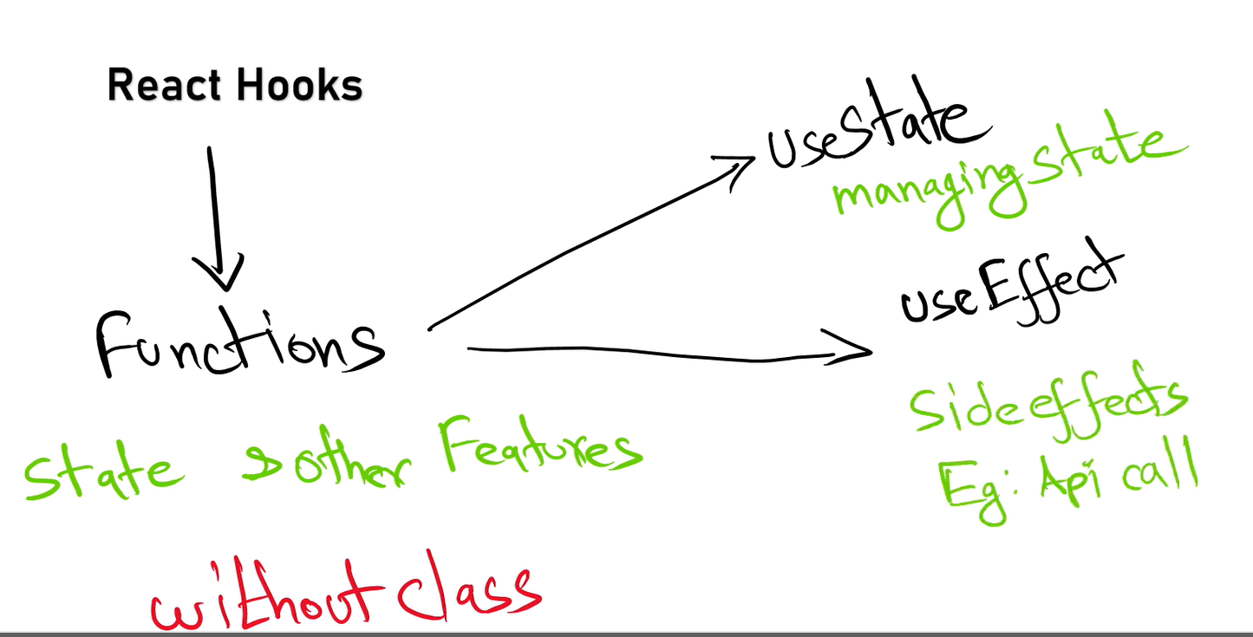
Parent to child pros?
Passing data from parent to child components in React provides benefits such as centralized data management, controlled data flow, component reusability, simplified state management, enhanced readability, encapsulation, and flexibility. This approach aligns with React’s design principles and helps build maintainable and scalable applications
what is the disadvantages of using JavaScript in reactjs?
If you developed react js using Javascript and we declare an object variable with string data type this will throw error at run time in production browser so will face type safety with javascript.
Authentication flow in React.js
Authentication Context: Use the React Context API to manage authentication state and provide it throughout your application.
Authentication Components: Create login and logout components and handle user authentication.
Protect Routes: Use a ProtectedRoute component to restrict access to certain routes based on authentication state.
Persistence: Persist authentication state using localStorage or sessionStorage.
API Integration: Implement API calls for login and manage authentication tokens as needed.
Side effects?
While the component is re-rendering the logic inside the component will execute again and again, in this case we have to isolate that particular logic using use Effect.
Can you explain useEffect with a real-time use case?
I use useEffect(() => {...}, []) to fetch data on mount.
For cleanup (like WebSockets or event listeners), I return a cleanup function:
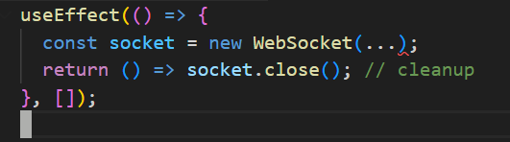
What’s the difference between useEffect, useLayoutEffect, and useInsertionEffect?
- useEffect Runs after the DOM is painted (asynchronous). Non-blocking – good for API calls, timers, subscriptions, The user sees UI updates immediately before effect runs.
- useLayoutEffect Runs synchronously after DOM mutations but before paint.
Blocking – used when you need to measure DOM or update layout before the browser paints
Can cause performance issues if overused.
- useInsertionEffect (introduced in React 18) runs before DOM mutations, mainly used for libraries injecting styles (e.g., Emotion).
What is Props drilling in React and how to overcome.
Passing of props to the multi-layer of components (Nested components) or is called props drilling but the properties passing may not useful for all components that is wasting of memory
Complexity increases code reusability.
Debugging becomes challenging in in order to overcome this we have use Context. Or using redux library we can avoid props drilling.
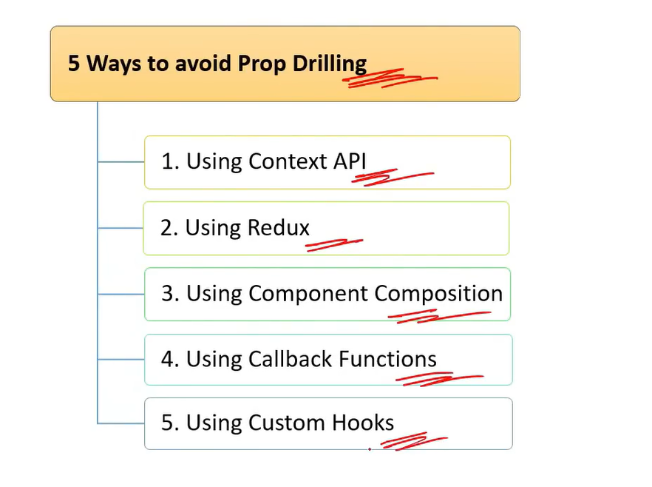
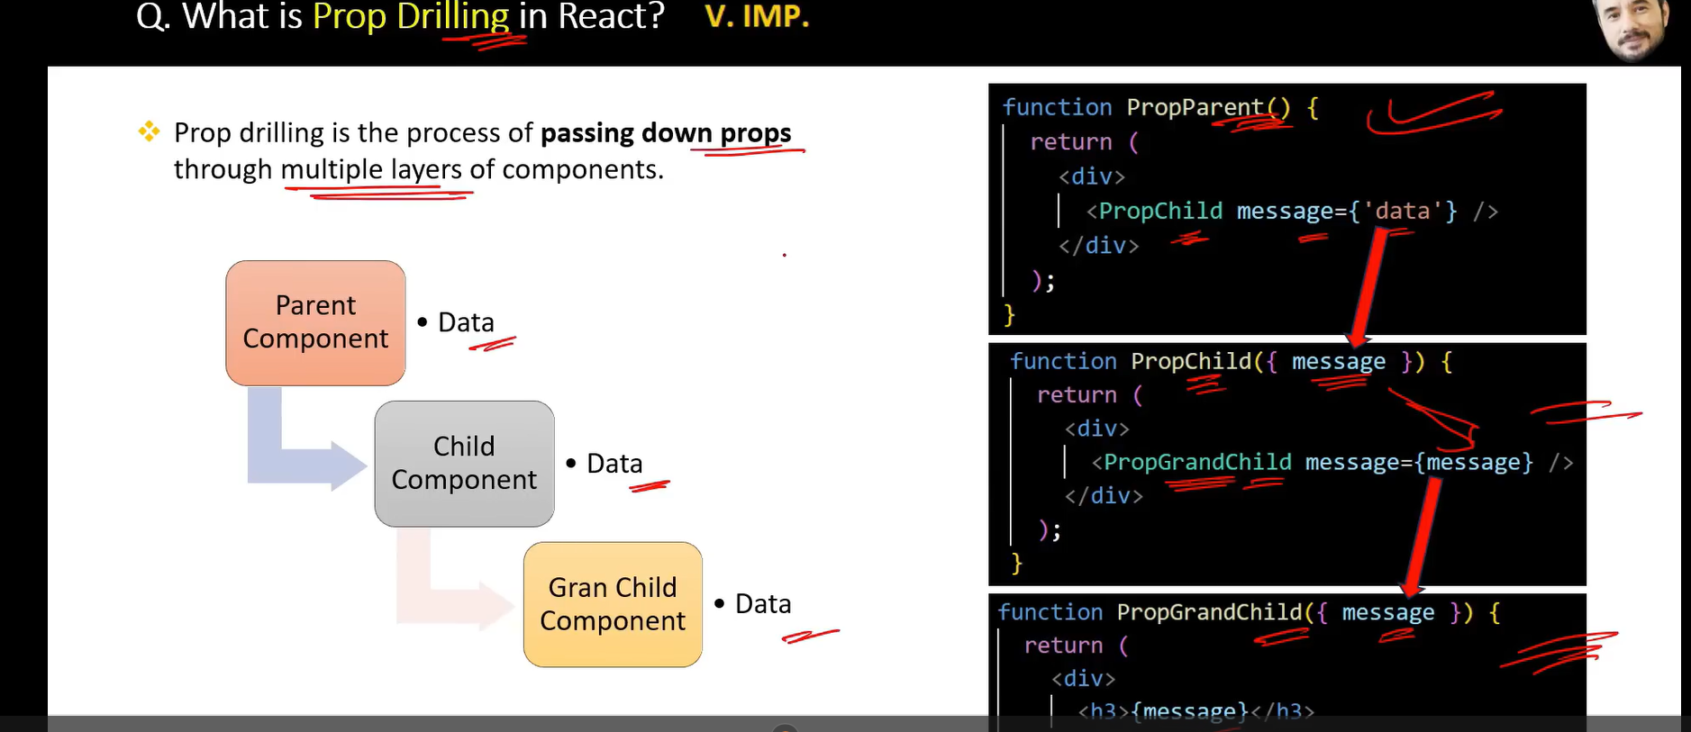
How to protect a Route.?
Protected route is used to handle the security which is avail from React router dom.
Stateless and stateful components?
Stateless Components:
- Do not manage internal state.
- Render UI based on props.
- Simpler and more focused on presentation.
Stateful Components:
- Manage internal state and lifecycle methods (class components) or side effects (functional components with hooks).
- Handle user interactions and complex operations.
- More complex and capable of managing state and side effects.
Purpose of React render Method?
The render method is crucial in React for defining the component’s UI based on its state and props. It:
- Describes the structure of the UI.
- Updates the UI when state or props change.
- Composes complex UIs using other components.
- Operates as a pure function, ensuring predictable UI updates.
Controlled and uncontrolled components?
Controlled Components:
- State Management: Form data is managed via React state.
- Predictable: The component’s state is the single source of truth.
- Event Handling: Input changes update React state.
- Advantages: Easier state management, validation, and debugging.
Uncontrolled Components:
- Ref Management: Form data is managed through the DOM.
- Less Control: React does not directly manage form data.
- Event Handling: Values are accessed directly from the DOM.
- Advantages: Less boilerplate, direct access to DOM values.
What is the difference between HTML and React event handling?
What are synthetic events in React?
What are inline conditional expressions?
What is the "key" prop and what is its benefit when used in arrays of elements?
What is the purpose of keys in React lists?
Keys help React identify which items changed, are added, or removed. They optimize re-renders by giving each list item a unique identity.
Wrong Practice: Using index as a key can lead to bugs during reordering.
What is prop drilling and how can you avoid it?
Prop drilling is passing props through multiple levels of components unnecessarily. It can be avoided using Context API or state management tools like Redux or Zustand.
Example:
Instead of passing theme from App → Layout → Header → Button, we used React.createContext and useContext to directly access it inside Button.
What are Pure Components?
*`React.PureComponent`* is exactly the same as *`React.Component`* except that it handles the `shouldComponentUpdate()`, the component will re-render by default whenever `shouldComponentUpdate` is called.
a Pure Component is a component that only re-renders when its props or state change.
What is lifting stateup?
Lifting state up involves moving state management to the closest common ancestor of components that need to share the state. This pattern helps in maintaining a single source of truth, synchronizing data between components, and simplifying state management in React applications.
What are Fragments?
What are stateless components?
What are stateful components?
How do you apply validation to props in React?
What are the limitations of React?
How do you apply styles in React?
What are portals in React?
What is state mutation and how to prevent it?
How do you conditionally render components?
How to bind methods or event handlers in JSX callbacks?
How to pass a parameter to an event handler or callback?
Conditional rendering in React lets us control what appears in the UI based on state, props, or any logic.
It uses standard JavaScript conditions like if, ? :, or && inside JSX.
In my projects, I’ve used it for showing loading states, error handling, and dynamic layouts like login/logout views or role-based dashboards.
How do you conditionally apply class attributes?
How do you write comments in React?
Dynamic Imports with React.Lazy?
- React.lazy: Allows you to load components dynamically, enabling code splitting.
- Dynamic import(): The mechanism behind React.lazy for asynchronous module loading.
- React.Suspense: Manages the loading state for components loaded lazily.
- Error Boundaries: Handle potential errors in loading components to improve user experience.

How do you structure a scalable React application?
I use a modular folder structure like:
src/
components/
pages/
hooks/
utils/
services/
store/
I encourage:
- Atomic design principles for components
- Centralized API service layer
- Environment-based config management
- Lazy-loaded routing setup
- Separation of concerns
As a lead, I emphasize code readability, maintainability, and testability.
What is Concurrent Rendering in React 18?
Concurrent rendering allows React to prepare multiple versions of the UI at the same time. It improves responsiveness and avoids UI blocking during heavy rendering. Features like automatic batching, transitions, and startTransition() help React prioritize urgent updates.
As a Tech Lead, I focus on using these APIs to ensure better user experience without performance drops.

How do you ensure code quality in a React project?
I enforce:
- Strict ESLint + Prettier rules
- Unit and integration tests using Jest, React Testing Library
- Code reviews with PR templates
- CI/CD integration for testing and linting
- Component documentation using Storybook
As a Tech Lead, I balance quality and velocity by automating checks and mentoring the team on best practices.
How do you handle SEO in a React application?
Since React is client-side rendered, SEO can be a challenge. For SEO-critical apps, I recommend:
- Server-side rendering (SSR) with Next.js
- Using React Helmet for dynamic meta tags
- Pre-rendering or static site generation where possible
- Ensuring crawlable, semantic HTML

What’s your approach to mentoring junior React developers?
I pair them with senior devs for code reviews, introduce component reuse and state management basics, and gradually give them ownership of modules. I also encourage best practices early—like meaningful naming, code comments, and testing. Regular 1:1s and shared learning sessions keep them engaged and growing.
How do you ensure code quality in your team as a Tech Lead?
- Code reviews with focus on clarity, performance, and security.
- Setup ESLint + Prettier for consistent code style.
- Maintain unit and integration test coverage.
- Automate builds, tests, and deploys using CI/CD pipelines (Jenkins/GitHub Actions).
- Encourage knowledge sharing, mentoring, and pair programming
Why does React use className instead of the class attribute?

Using React.lazy and dynamic imports effectively can help improve the performance of your React application by reducing the initial bundle size and loading components only when they are needed.
It helps improve the performance of your React application by loading only the necessary code when it’s needed. This can reduce the initial load time of your application and improve user experience.
Dynamic Imports with React.lazy:**
- `React.lazy` allows you to load a component lazily when it’s needed.
- You wrap your lazy-loaded component in a `React.Suspense` component, which allows you to specify a fallback UI (e.g., a loading spinner) while the component is being loaded.

**Example:**
```jsx
import React, { Suspense } from 'react';

const LazyComponent = React.lazy(() => import('./LazyComponent'));

function App() {
return (
<div>
<Suspense fallback={<div>Loading...</div>}>
<LazyComponent />
</Suspense>
</div>
);
}
```

2. Dynamic Import with React Router:**
- If you’re using React Router for navigation, you can also dynamically import route components.

**Example:**
```jsx
import React, { Suspense } from 'react';
import { BrowserRouter as Router, Route, Switch } from 'react-router-dom';

const HomePage = React.lazy(() => import('./HomePage'));
const AboutPage = React.lazy(() => import('./AboutPage'));

function App() {
return (
<Router>
<Suspense fallback={<div>Loading...</div>}>
<Switch>
<Route path="/home" component={HomePage} />
<Route path="/about" component={AboutPage} />
</Switch>
</Suspense>
</Router>
);
}
3. **Webpack Code Splitting:**
- For more advanced scenarios, you can configure Webpack to split code into separate bundles based on your application's needs. This usually involves setting up Webpack’s optimization options, like `splitChunks`.

Example Configuration (Webpack):**
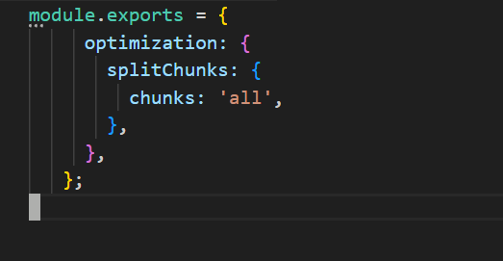
**Benefits of Code Splitting:**

- **Improved Performance:** Reduces the amount of JavaScript needed on the initial page load.
- **Faster Load Times:** Users only load the components they need, which can lead to quicker interactions.
- **Enhanced User Experience:** By deferring the loading of non-critical components, users see meaningful content faster.

FORMs?
React Forms are the components used to collect and manage the user inputs.
Events?
React Events are user interactions with the web application
Difference in ES5 ES6?
- ES5: The version before ES6, with more basic features and less syntactic sugar.
- ES6: Introduced many new features, including let, const, arrow functions, classes, modules, template literals, destructuring, default parameters, rest and spread operators, and promises.

Bundle of react?
Bundling in React involves combining JavaScript, CSS, and other assets into optimized files to enhance performance and reduce the number of HTTP requests. Tools like Webpack, Vite, and Parcel are commonly used to handle this process. Bundling not only helps in optimizing load times but also in managing and organizing code effectively.

Redux
What is Redux?
Redux is a state management library used to manage global state across a React application in a predictable, centralized, and debuggable way.
What is the purpose of Redux in a React application? When should you use Redux instead of useState or useContext?
At when we can Use Redux:
- The app has complex global state (e.g., user auth, theme, cart, dashboard data)
- Many components need shared data
- You want predictability and debugging
- The app requires middleware for async logic (e.g., API calls using Redux Thunk/Saga)
How to use Redux in Functional Component ?
What is Redux ?
Redux is a predictable state management library for JavaScript apps, commonly used with React.
It helps manage global state — the data that needs to be shared across many components — in a centralized and consistent way.
Why we have to use redux ?
- Helps when many components need access to the same state (e.g., authentication, theme, language, cart).
- Improves testability and debuggability.
- Useful for handling complex async flows (e.g., API calls) using Redux Thunk or Redux Saga.
What is Reducer ?
A reducer is a pure function that takes the current state and an action, and returns a new updated state — without mutating the original state.
How redux store is available to react app ?
We use the <Provider> component from the react-redux library to inject the Redux store into the React component tree.
What is redux Logger ?
Redux Logger is a middleware that logs every action dispatched and the resulting state in the console.
It is mainly used for development to help visualize:
- The action type dispatched
- The previous state
- The next state
Authentication vs Authorization?
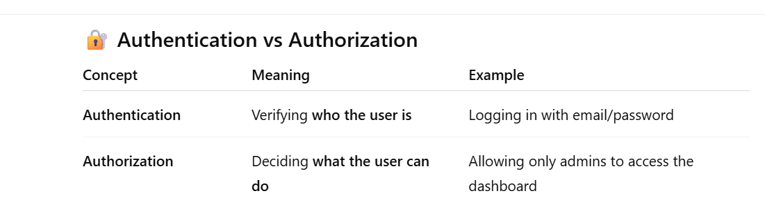
Authentication
- It's the first step in securing an app.
- The goal: confirm the user’s identity using credentials like:
- Email/password
- OAuth (Google, GitHub, etc.)
- Token-based login (JWT)
Authorization
- Happens after authentication.
- Determines what actions or routes a user is allowed to access.
How to call the reducer ?
You don’t call a reducer directly — instead, you dispatch an action, and Redux internally calls the corresponding reducer to update the state.
Can you explain Redux flow ? ()
Redux is a state management library commonly used with React to manage the state of applications in a predictable way. The Redux flow refers to the sequence of steps and interactions involved in managing state changes within a Redux-based application.
Action Creation: An action is created (either directly or using an action creator).
Dispatching Action: The action is dispatched to the store.
Reducer Handling: The store sends the action to the appropriate reducer.
State Update: The reducer processes the action and returns a new state.
State Change Notification: The store updates its state and notifies subscribed components or listeners.
Component Rendering: Components access the updated state (usually via mapStateToProps or hooks like useSelector) and re-render based on the new state.
react-redux hooks: useSelector, useDispatch, Provider
Redux Toolkit (modern approach)
Smart example: Counter or Todo using Redux
Real-time scenario Q&A
Coding Exercise
What is the output of below code
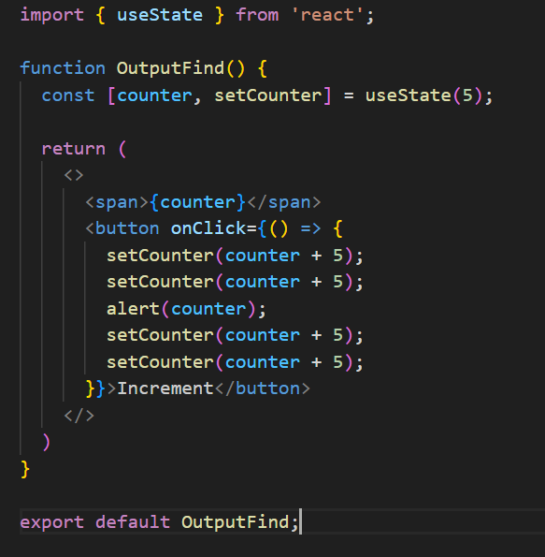
On screen:
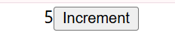
In alert popup:
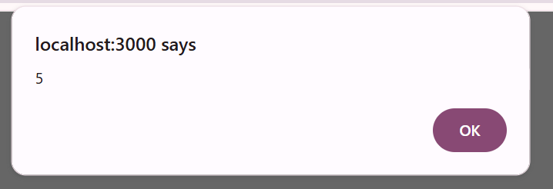
alert(counter) shows the value before any updates take effect:
  - Since state updates are asynchronous, alert(counter) will show the value before any of the setCounter calls are applied.
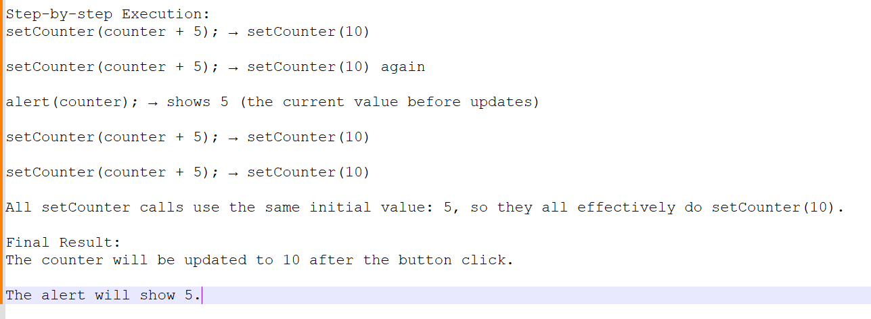
In order to make work do below changes.
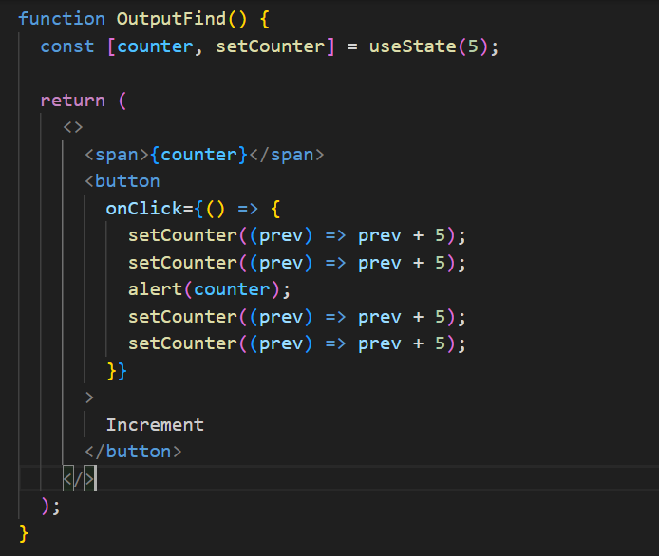
- Alert shows: 5
- Final counter value: 10 (with original code)
- Final counter value with functional updates: 25 (if using prev => prev + 5 four times)
What is the output of below code
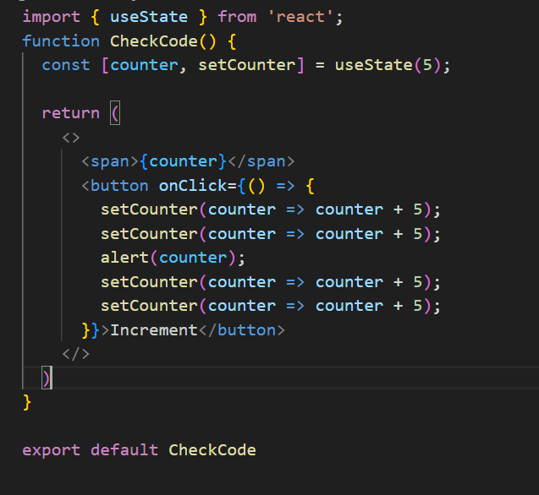
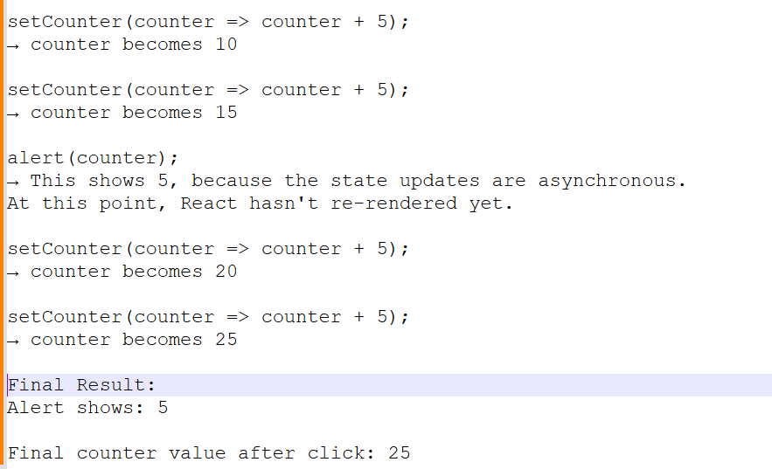

What is the output of span after one click?
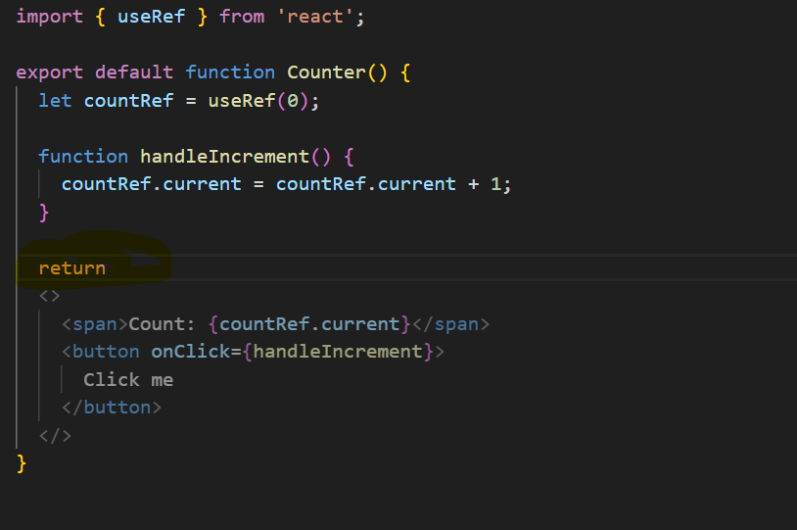
The return statement ends right after return, so the JSX is not returned at all — JavaScript automatically inserts a semicolon after return!
So the JSX inside is never returned, meaning the component returns nothing — React renders nothing.

What is the outcome of below code after button click?
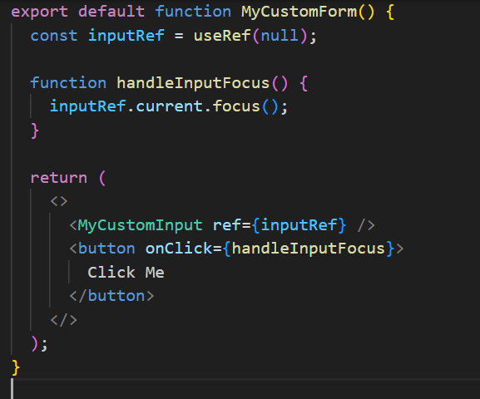
You will get a runtime warning or error in the console:
You can’t directly attach a ref to a functional component like <MyCustomInput />. Because ref is meant to attach to a DOM node, not to a function.

What is the outcome of number of clicks after 3 button clicks?
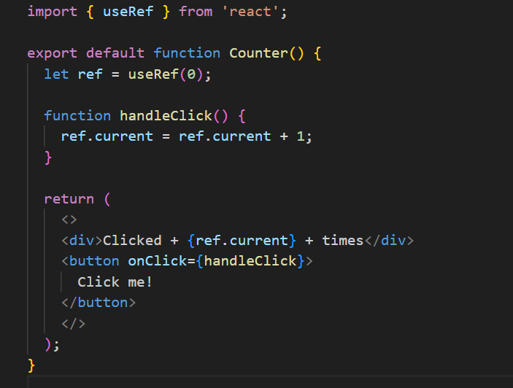
useRef updates do not trigger re-render in React.

What does this code do?
const [items, setItems] = useState([1, 2, 3]);
const newItems = items; //This doesn't clone the array; it's a reference.
newItems.push(4);// Mutates the original array in-place.
setItems(newItems); //tries to update state with the same array (by reference).
The array becomes [1, 2, 3, 4] but React may not re-render, because the reference to the array hasn't changed.
React re-renders only when state identity (reference) changes. In this case, items and newItems are the same reference, so React might skip rendering.
Correct Approach : setItems([...items, 4]);
NEXT
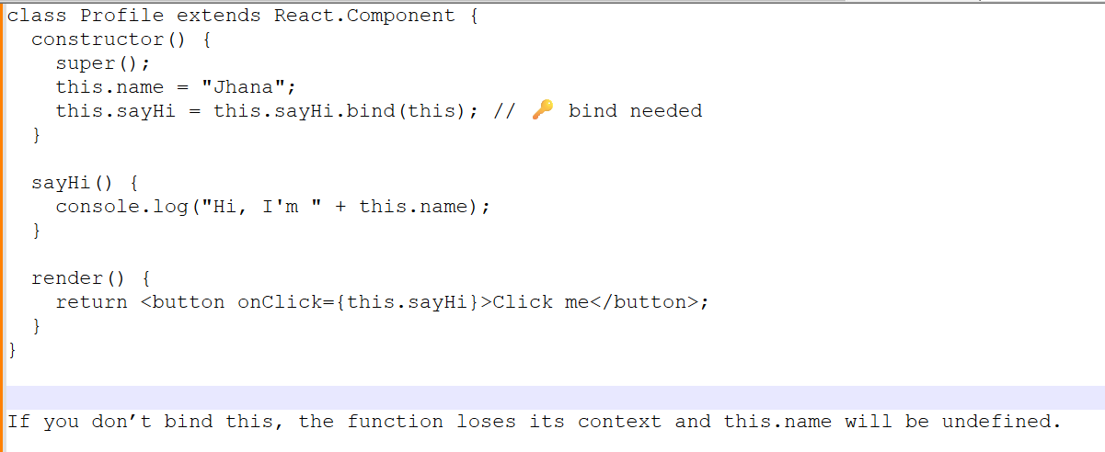
NEXT

NEXT

NEXT

SENARIO BASED QUESTIONS:
How will you handle complex forms with 20+ fields?
When dealing with complex forms containing 20+ fields, scalability, maintainability, and performance are the top priorities. A few strategies I would use:
1.Form State Management: Instead of keeping everything in component-level state, I would use libraries like React Hook Form or Formik because they provide:
Built-in validation
Better performance (minimizes unnecessary re-renders)
Easy integration with UI components
2.Divide into Logical Sections (Step Forms): Break down the form into smaller steps/tabs. For example:
Step 1: Personal details
Step 2: Address details
Step 3: Preferences This improves usability and reduces cognitive load.
3.Dynamic Form Rendering: Store form configuration (labels, input types, validation rules) in a JSON schema and render inputs dynamically. Example: instead of hardcoding 20+ inputs, loop through a config array.
Makes it easy to maintain and update forms in the future.
4.Validation Strategy: Client-side validation using Yup/Zod schemas.
Server-side validation to avoid bypass.
Show validation errors inline to improve UX.
5.Performance Optimization:
Use debouncing for expensive validations.
Lazy load non-essential sections.
Memoize form field components to prevent unnecessary re-renders.
6.Accessibility (a11y): Proper labeling with aria-labels and for attributes.
Keyboard navigation.
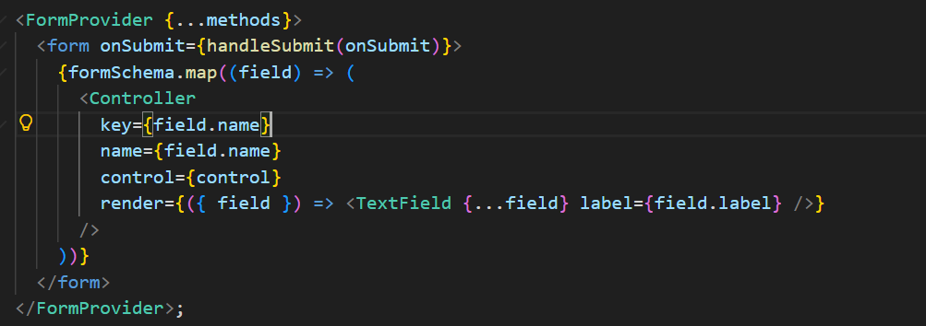
2. Supporting Dark Mode at Scale
Approach: Use CSS variables at the root and toggle a theme class on the <html> or <body> element.
Key Tactics:
CSS Variables: Define --bg-color and --text-color and avoid hardcoding values .
System Detection: Use the prefers-color-scheme: dark media query.
Persistence: Store user choice in localStorage.
Accessibility: Ensure WCAG AA color contrast and avoid pure black (#000) for better readability (use #121212) .
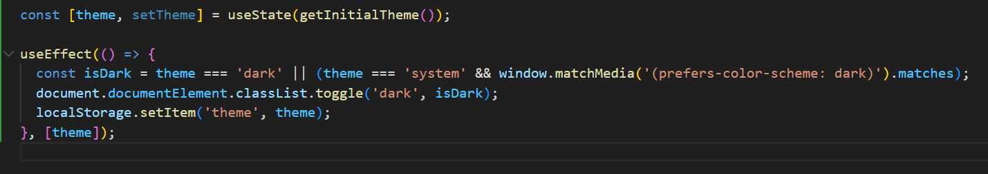
3.Securing Apps Against XSS Attacks
Goal: Prevent malicious scripts from being injected into the application.
Defenses:
Sanitization: Use DOMPurify to clean untrusted HTML.
Content Security Policy (CSP): Block inline scripts via HTTP headers .
React Defaults: Rely on React’s auto-escaping, and avoid dangerouslySetInnerHTML unless sanitized.
Cookies: Use HttpOnly and Secure flags for tokens.
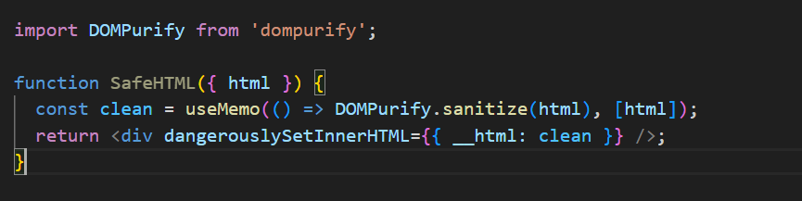
4. Performance Optimization (Fixing Sluggish Apps)
Diagnosis: Use Chrome DevTools (Performance panel) and React DevTools Profiler to find "hot" components and long tasks .
Fix Patterns:
Stop Re-renders: Use React.memo for pure components and useCallback/useMemo for stable handlers and heavy computations .
Virtualization: Use react-window for huge lists.
Code Splitting: Implement React.lazy and Suspense for route-based loading.
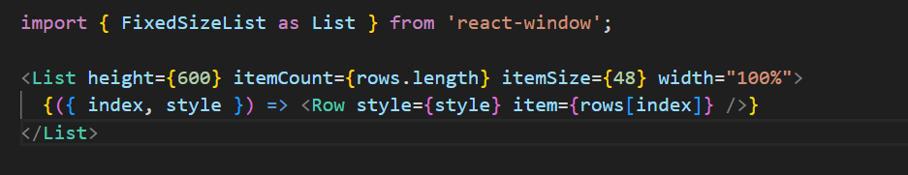
5. Offline Capabilities and Caching
- Offline: Use Service Workers (PWA) to cache assets and IndexedDB for local data storage.
- Caching Issues: Solve stale data by using Cache Busting (hashed filenames like main.abc123.js) and setting proper Cache-Control headers .
